**2o21 Prayer List**

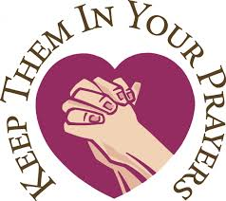

**May 15, 2021 – May 23, 2021**

**Seventh Sunday of Easter**

**Saturday: May 15, 2021** Acts 1:15-17, 20a, 20c-26;

1 John 4:11-16; John 17:11b-19

4:00 pm St. Mary: **†** Arthur, Sr. & **†** Mary Leontine Belisle

**†** Mario Paul & **†** Peter Gaudreau

5:30 pm St. Benedict: **†** Dale Nadeau

**Sunday: May 16, 2021** Acts 1:15-17, 20a, 20c-26;

**Please call the parish office at**

**(802) 334-5066 if you would**

**like to add a name to the Prayer List.**

1 John 4:11-16; John 17:11b-19

8:30 am St. Edward: Living & **†** Deceased Former Members

of the Daughters of Isabella & **†** Adrien Patenaude

9:30 am St. Mary: **†** Anna Sanville

10:30 am St. James: **†** Brian Goulet, **†** Paul King & **†** Bobby Caouette

Jenny Kirsch

Rita Lantagne

Nancy Lawson

Sue Leavitt

Robbie Lynn LeBlanc

Elizabeth Lemieux

John & Donna Major

Thomas McLellan

Purie Mesina

Fr. Curtis Miller

Francois Morin

Joshua Noble

Thomas J. Perrino

Michael Poginy

Roger Raboin

Cecile Ricard

John Ricard

Robert Rivard

Fr. Shawn Roberson

Allen Robinson

Paul Shilale

Cheryl Silveria

Bernadette Stanis

Regina Switser

Neila Venne & Siblings

Mark Wilson

Yvonne Wood

Sandy Worth

Richard Wyman

11:00 am St. Mary: **†** Joan Cote & **†** Joseph Fournier

Tanner Blais

Gabrielle Bolton

Yolande Brasseur

Yolande Bronson

William Brooks

Anna, Restituta, Andrew,

Mary & Josephine Buono

Felix Chaput

Sara Chaput

Kevin Charboneau

Steve Coggin

Adele Comeau

Claire Comeau

Lise Comeau

Stephen Comeau

Claude Cote

Loran Cote

Andrew Delabruere

Brenda Deslandes

Marcel Deslandes

Paul Diette

Jean Diette

Fr. Michael Dobbins

Nancy Dowling

Maci Fournier

Kathy Huffman

Carol Janson

Bernadette Kelley

Shayla Kippen

**Monday: May 17, 2021** Acts 19:1-8; John 16:29-33

9:00 am St. Mary: Vermont Families & Children in Crisis

4:00 pm St. Mary: Nursing Home & Homebound Residents

**Tuesday: May 18, 2021** Acts 20:17-27; John 17:1-11

**Saint John I: Pope & Martyr**

9:00 am St. Mary:  Those on Our Parish Prayer List

4:00 pm St. Mary: Intentions of the Vocationist Fathers

**Wednesday: May 19, 2021** Acts 20:28-38; – 18:1; John 17:11b-19

9:00 am St. Mary: **†** Maureen Fountain

4:00 pm St. Mary: Those Still Suffering from the Covid Pandemic

5:30 pm St. Edward: **†** Fr. John Hamilton

**Thursday: May 20, 2021** Acts 22:30, 23:6-11; John 17:20-26

**Saint Bernadine of Sienna: Priest**

9:00 am St. Mary: For the People of India

4:00 pm St. Mary: **†** Jacqueline & **†** Jon Lague

**Friday: May 21, 2021** Acts 25:13-21; John 21:15-19

**Saint Christopher Magalines: Priest & Companions: Martyrs**

9:00 am St. Mary: **†** Gabrielle Carr

11:00 am St. James: Increase in Vocations to the Priesthood

4:00 pm St. Mary: Rick Bouffard on his Birthday

& **†** Richard Bergeron

**Saturday: May 22, 2021**  Acts 28:16-20, 30-31; John 21:20-25

**St. Isidore: Patron Saint of Farmers**

9:00 am St. Mary: **†** Anthony Lague

**Pentecost Sunday**

**Saturday: May 22, 2021** Acts 2:1-11;1 Corinthians 12:3b-7,12-13;

John 17:20:19-23

4:00 pm St. Mary: **†** Winston Hammond & **†** Danielle Carpenter

1:00 pm St. Mary: Confirmation





5:30 pm St. Benedict: Intentions of the Newly Confirmed

**Prayer for the Sick**

**Father God, we lift up those who are facing illness today.**

**We ask that you bring healing, comfort and peace to their**

**bodies.**

**Calm their fears and let them experience the healing power of Your love.**

**In Jesus’ name we pray. Amen.**

**Sunday: May 23, 2021** Acts 2:1-11;1 Corinthians 12:3b-7,12-13;

John 17:20:19-23

8:30 am St. Edward: **†** Virginia Holbrook & **†** Albert Sicotte

of the Daughters of Isabella & **†** Adrien Patenaude

9:30 am St. Mary: **†** Fabien & **†** Beverley Poutre

10:30 am St. James: **†** Jeanne Henry & **†** Brian Goulet

11:00 am St. Mary:**†** Jeremy Maxwell & **†** Esperanza Robles

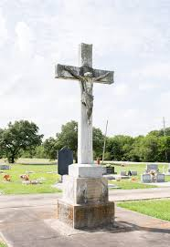

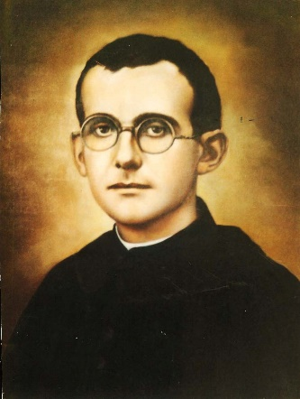

**Blessed Father Justin to be Canonized**

Blessed Justin Russolillo, an Italian priest who founded the Society of Divine Vocations for men and the Vocationist Sisters will be named a saint, causing joy and gratitude among the Vocationist men and women who serve in in Vermont, the United States and throughout the world. world. Pope Francis approved the canonization on May 3rd but said that the date would be determined later because of the ongoing COVID-19 pandemic.

In addition to Mater Dei Parish, Vocationist priests serve at Our Lady of Seven Dolors Church in Fair Haven, St. John the Baptist Church in Castleton, St. Paul Church in Orwell, St. Frances Cabrini Church in West Pawlet and St. Matthew of Avalon Chapel in West Castleton in Vermont.

Blessed Justin was born in Italy in 1891 and ordained a priest in 1913. That year, he founded the first community of the Society of Divine Vocations, which came to be known as the Vocationist Fathers, to foster and promote vocations to the priesthood, religious life, and holiness among all God’s people.

The Vocationists’ spirituality stems from Blessed Justin’s conviction that all people are called to holiness and that their ultimate goal is to achieve divine union. Vocationists greet each other with the words “Jesus, Mary & Joseph” to invoke the Holy Family, and part with the words “Be Holy” rather than good-bye to help people connect to heaven.

Blessed Justin died in 1955 at the Vocationist Fathers’ Motherhouse in Italy. He was proclaimed venerable in 1997 and beatified in 2011.

Today there are hundreds of priests, brothers, sisters, novices, and religious serving in the spirit of Blessed Justin who devoted his life to fulfilling the need for religious vocations throughout the world. Members of the congregation promote vocations with the goal of bringing all members, and through them, the whole world, to perfect union with the Father, Son and Holy Spirit.

The Vocationist Fathers first arrived in the United States in 1962, and now serve a dozen parishes in Vermont, New York, New Jersey, Massachusetts, and Florida.